# Project 2 Contextual Inquiry and Analysis: Flow Model

## Sketch

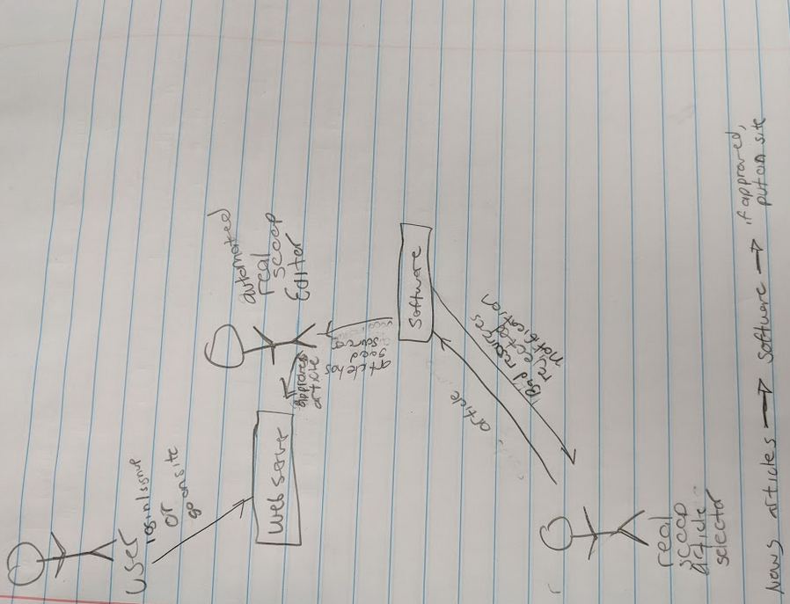

## Software Drawing

